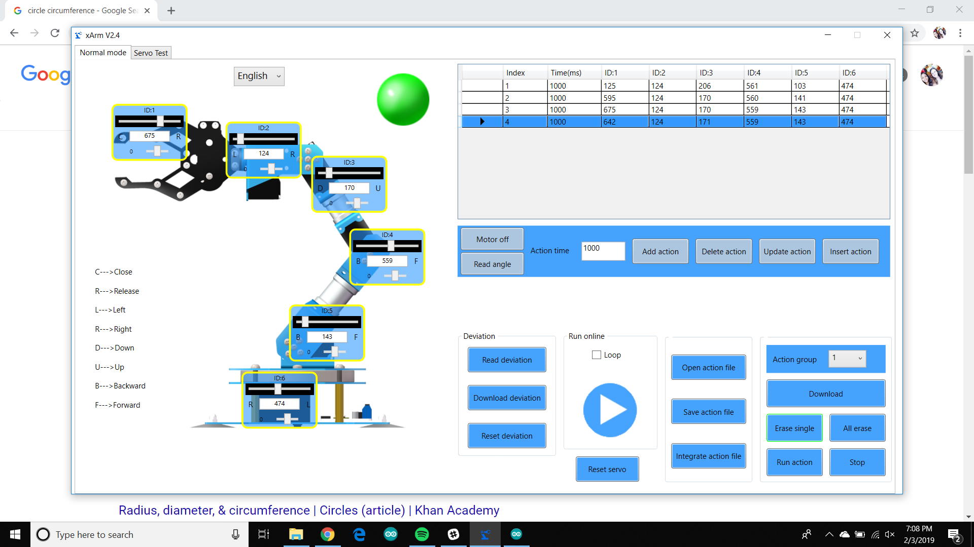

Highlighted is angle read when servo grasps the needle the action before it is the action to close all the way. This shows that it will read the actual angle and not just what is read. The first action tells the servo to open the claw as wide as possible and as close to the ground as possible. The second action stops slightly bigger than the width of the needle. (Action Group 1)

<https://maker.pro/raspberry-pi/tutorial/how-to-connect-and-interface-raspberry-pi-with-arduino>

Serial1 needed for the RX and TX pins – 19(RX), 18(TX)

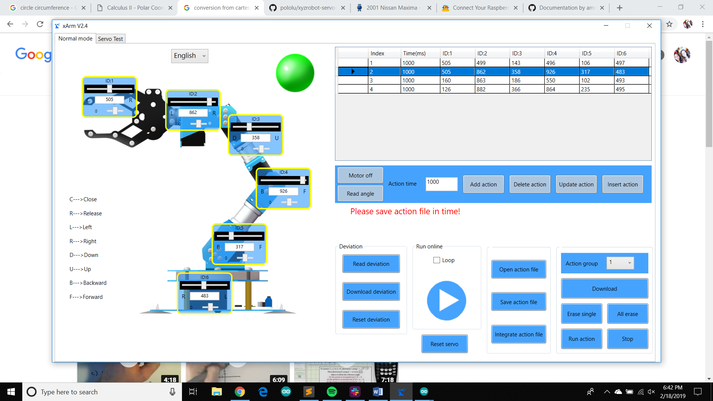

The first action is the max extension of the xArm with the narrow grip. The second action is the min extension of the xArm with the narrow grip. The third action is the max extension of the xArm with the wide grip. The fourth action is the min extension of the xArm with the wide grip. All actions were taken with the xArm going straight forward and straight back.

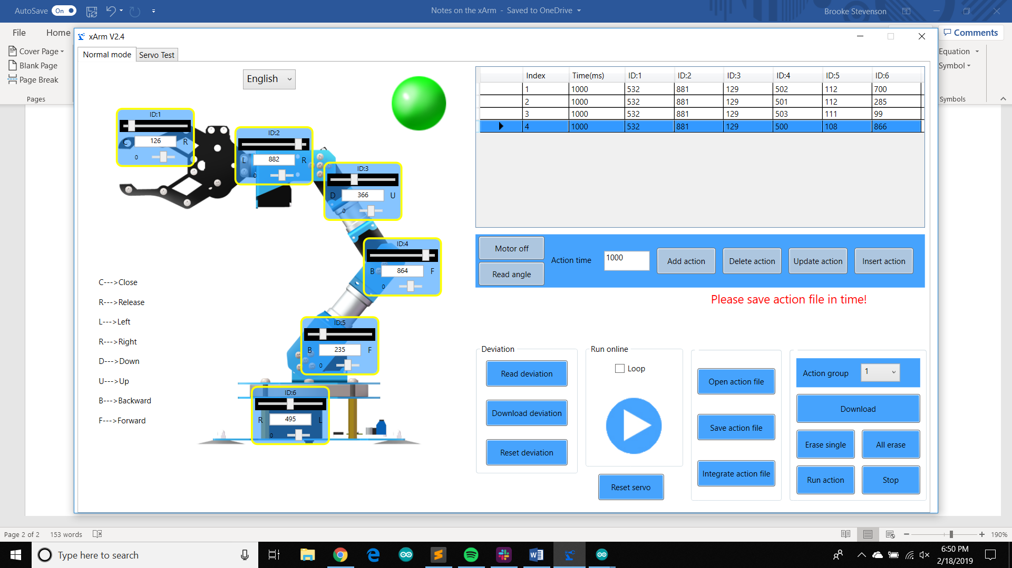

The first action is the xArm moved to the left in line with the front corner of the robot. The second action is the xArm moved to the right in line with the front corner of the robot. These should serve as reference for the max range of motion for the xArm to be able to safely be able to pick up a needle. The third action is the 0 point of the total range of motion for the xArm (a true semi-circle range), this is for the right side of the robot. The right side in reference to if you were looking at the robot from the back where the camera pole is. The fourth action is the 180 degree point for the total range of motion for the xArm (a true semi-circle range), this is the left side of the robot.

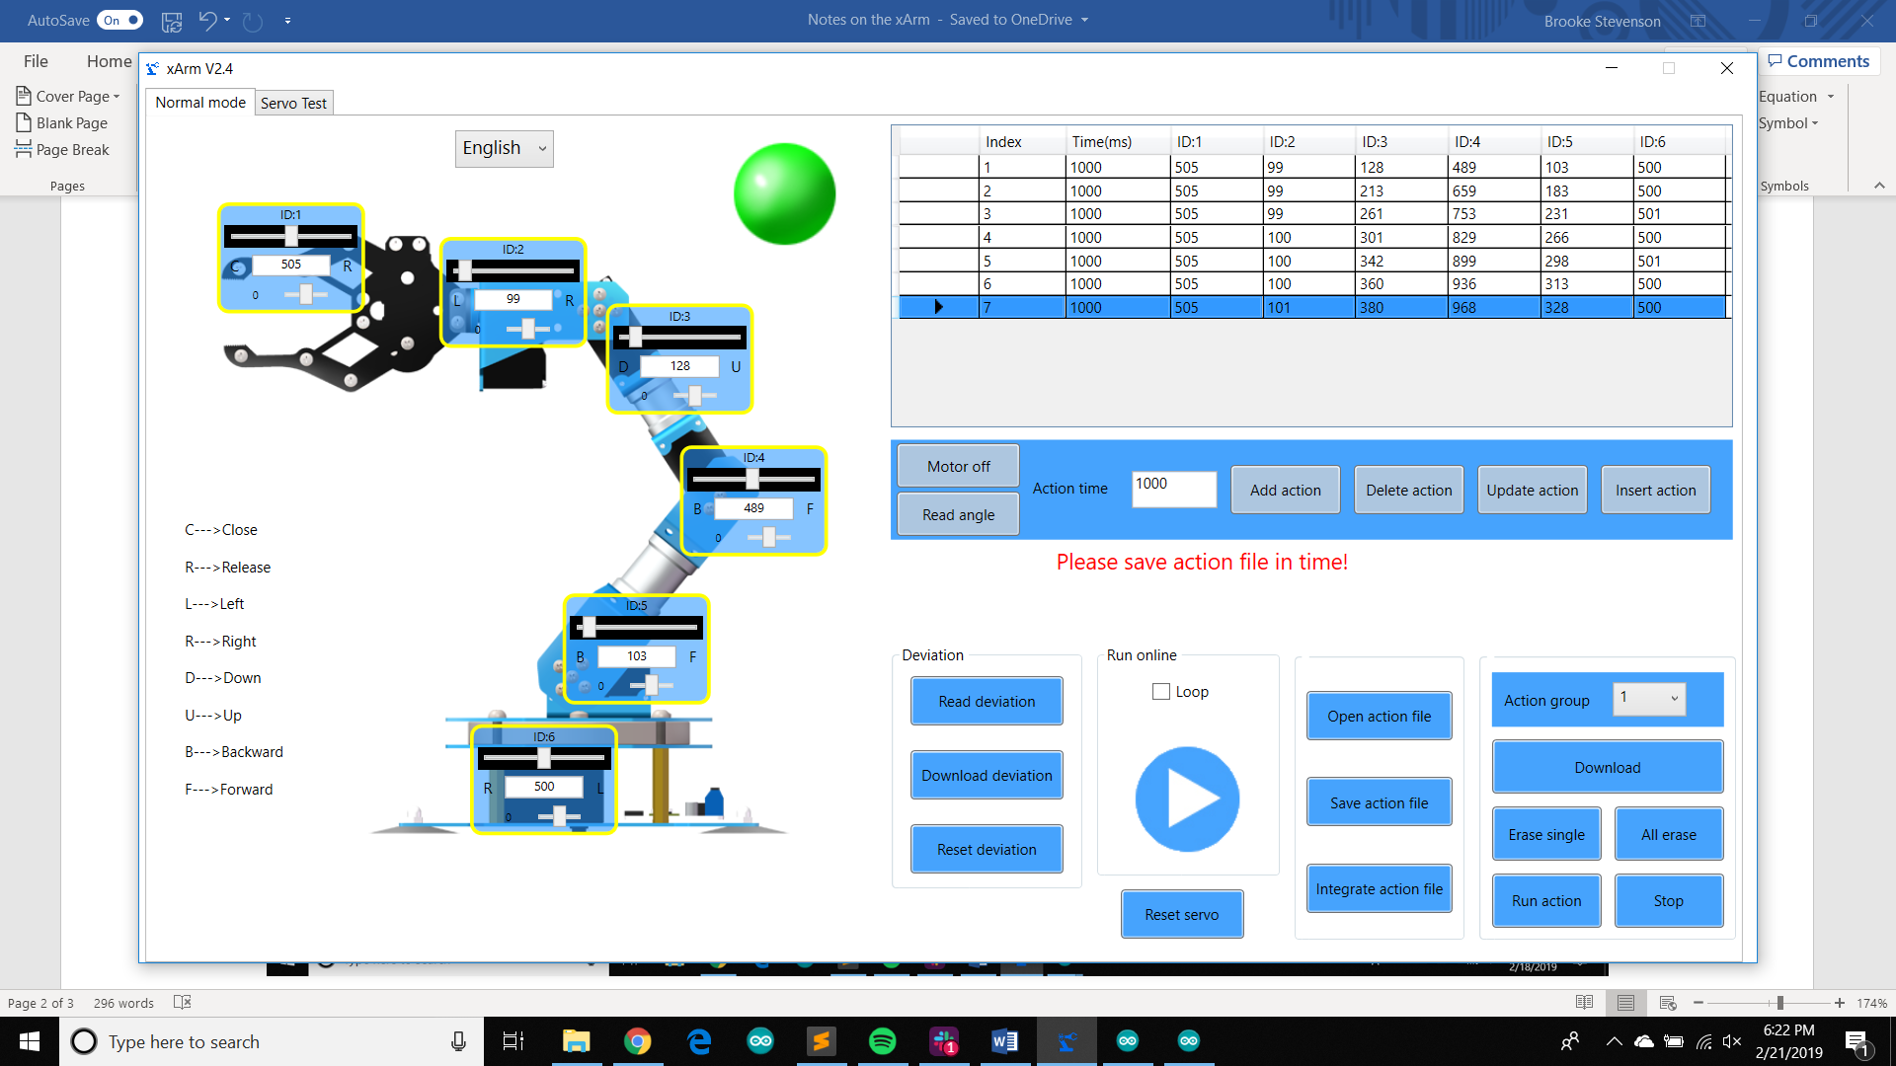

The first action is the xArm fully extended in front of the robot to achieve the max reach. The next actions are just slow movements of the xArm going towards the robot. The last action is the xArm is the minimum reach in front of the xArm.

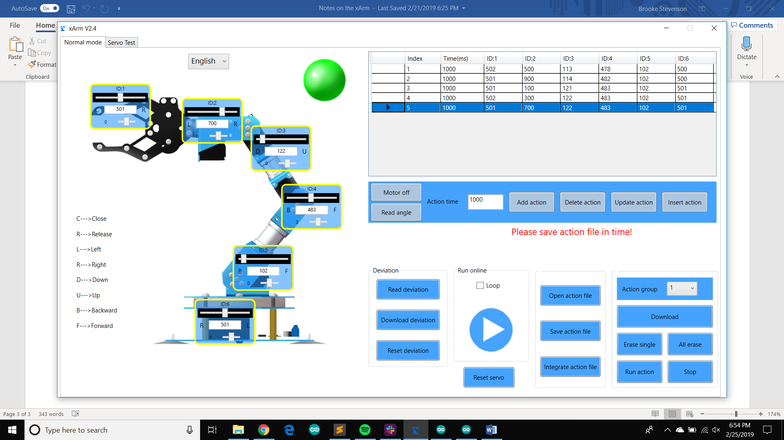

These are the actions for the xArm hand positions. In these we are only concerned with ID:2 which controls the rotation of the hand. The first action is the hand at the 90 degree point, where the hand is parallel to the robot. The second action is the hand rotated to the right which is the equivalent of 180 degrees, which is also the same position as 0 degrees. The third action is the hand rotated to the left which is the equivalent to 0 degrees (same as 180 degrees in terms of orientation for picking up the needle). Fourth action is the 45 degrees angle and the fifth action is the 135 degree angle. \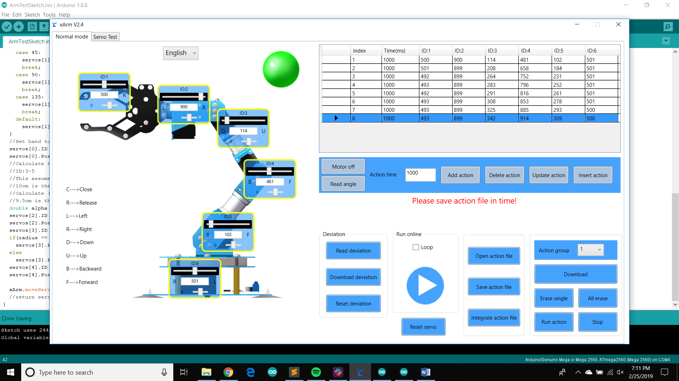

These are the actions showing the xArm’s movements in terms of the radius. We are looking at ID:3,4, and 5. The first action is the full extended xArm reach which is approximately 19 cm. The following actions are the xArm movements adjusting by 1 cm till it reaches it’s minimum reach which is approximately 12 cm.

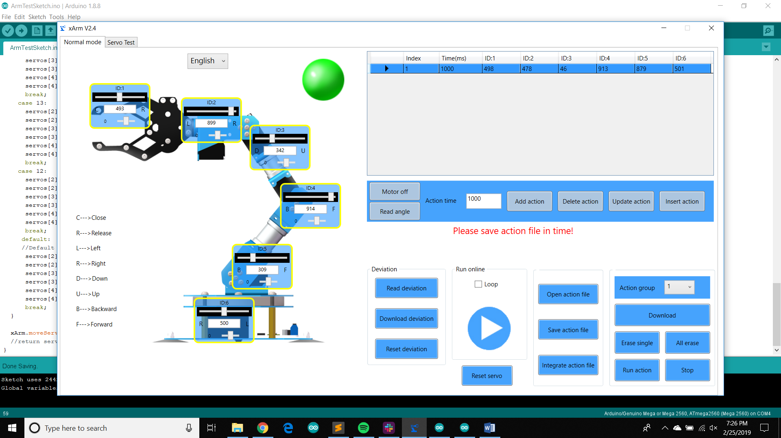

This is the default resting position for the xArm.

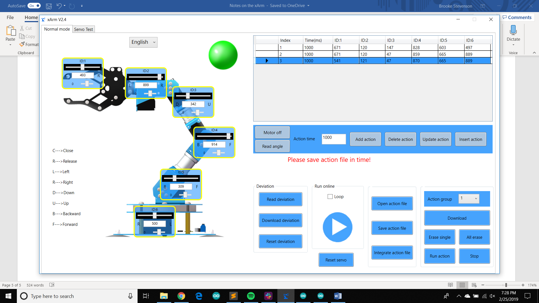

This is the action group of dropping the syringe after picking it up.